ISM 6225

Distributed Information systems

Osman Rahman

Screenshot of outputs (Questions 1 – 6). Below screenshots consist of successful executed code for each question.

Question 1

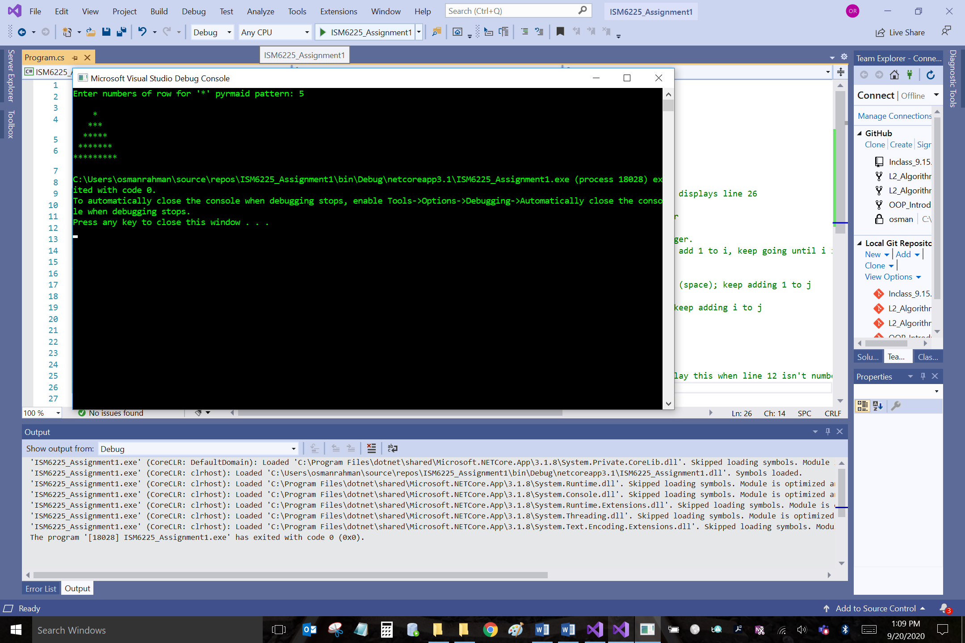

Question 2

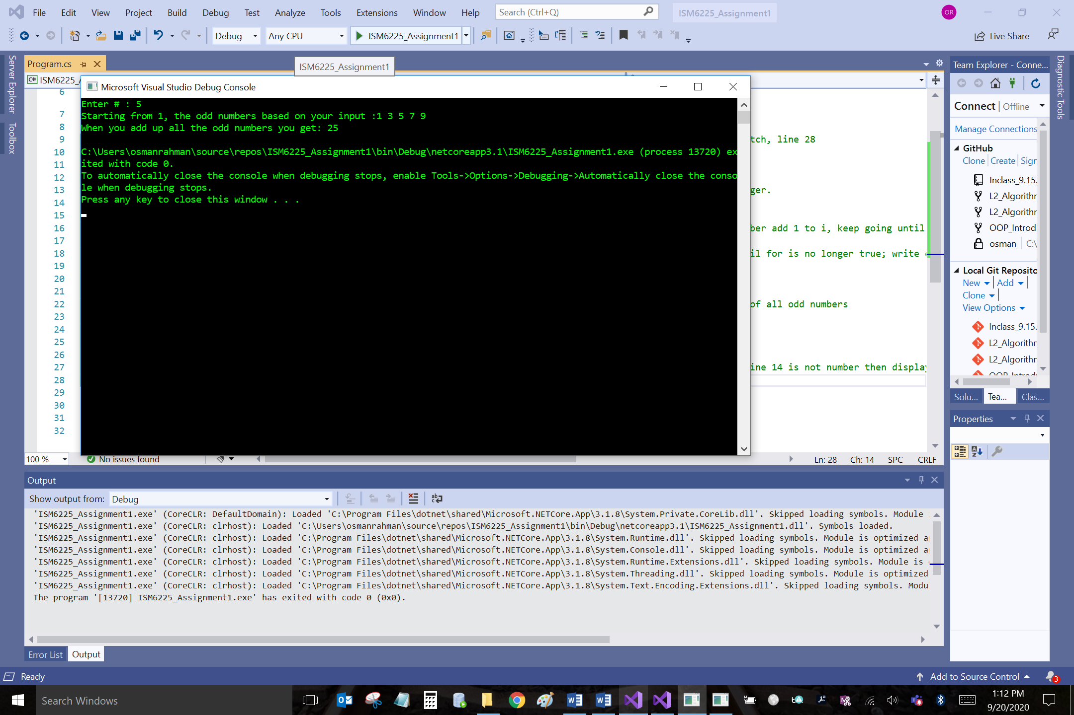

Question 3

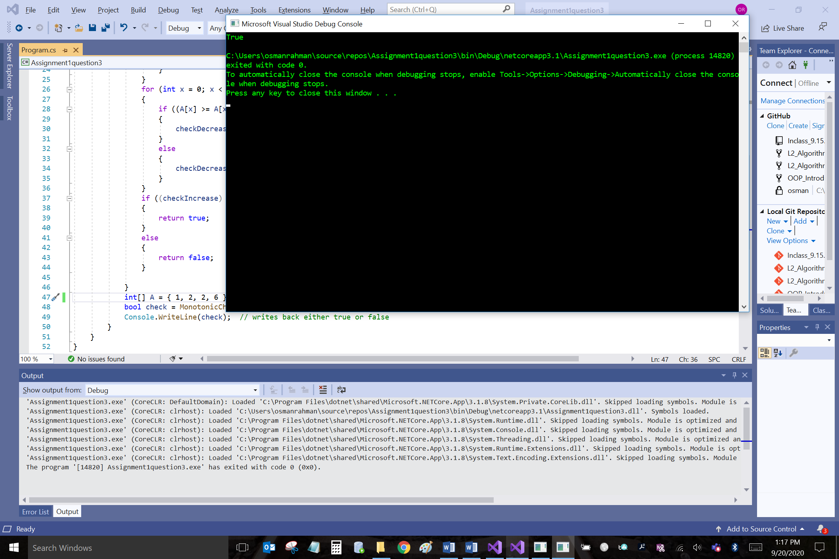

Question 4

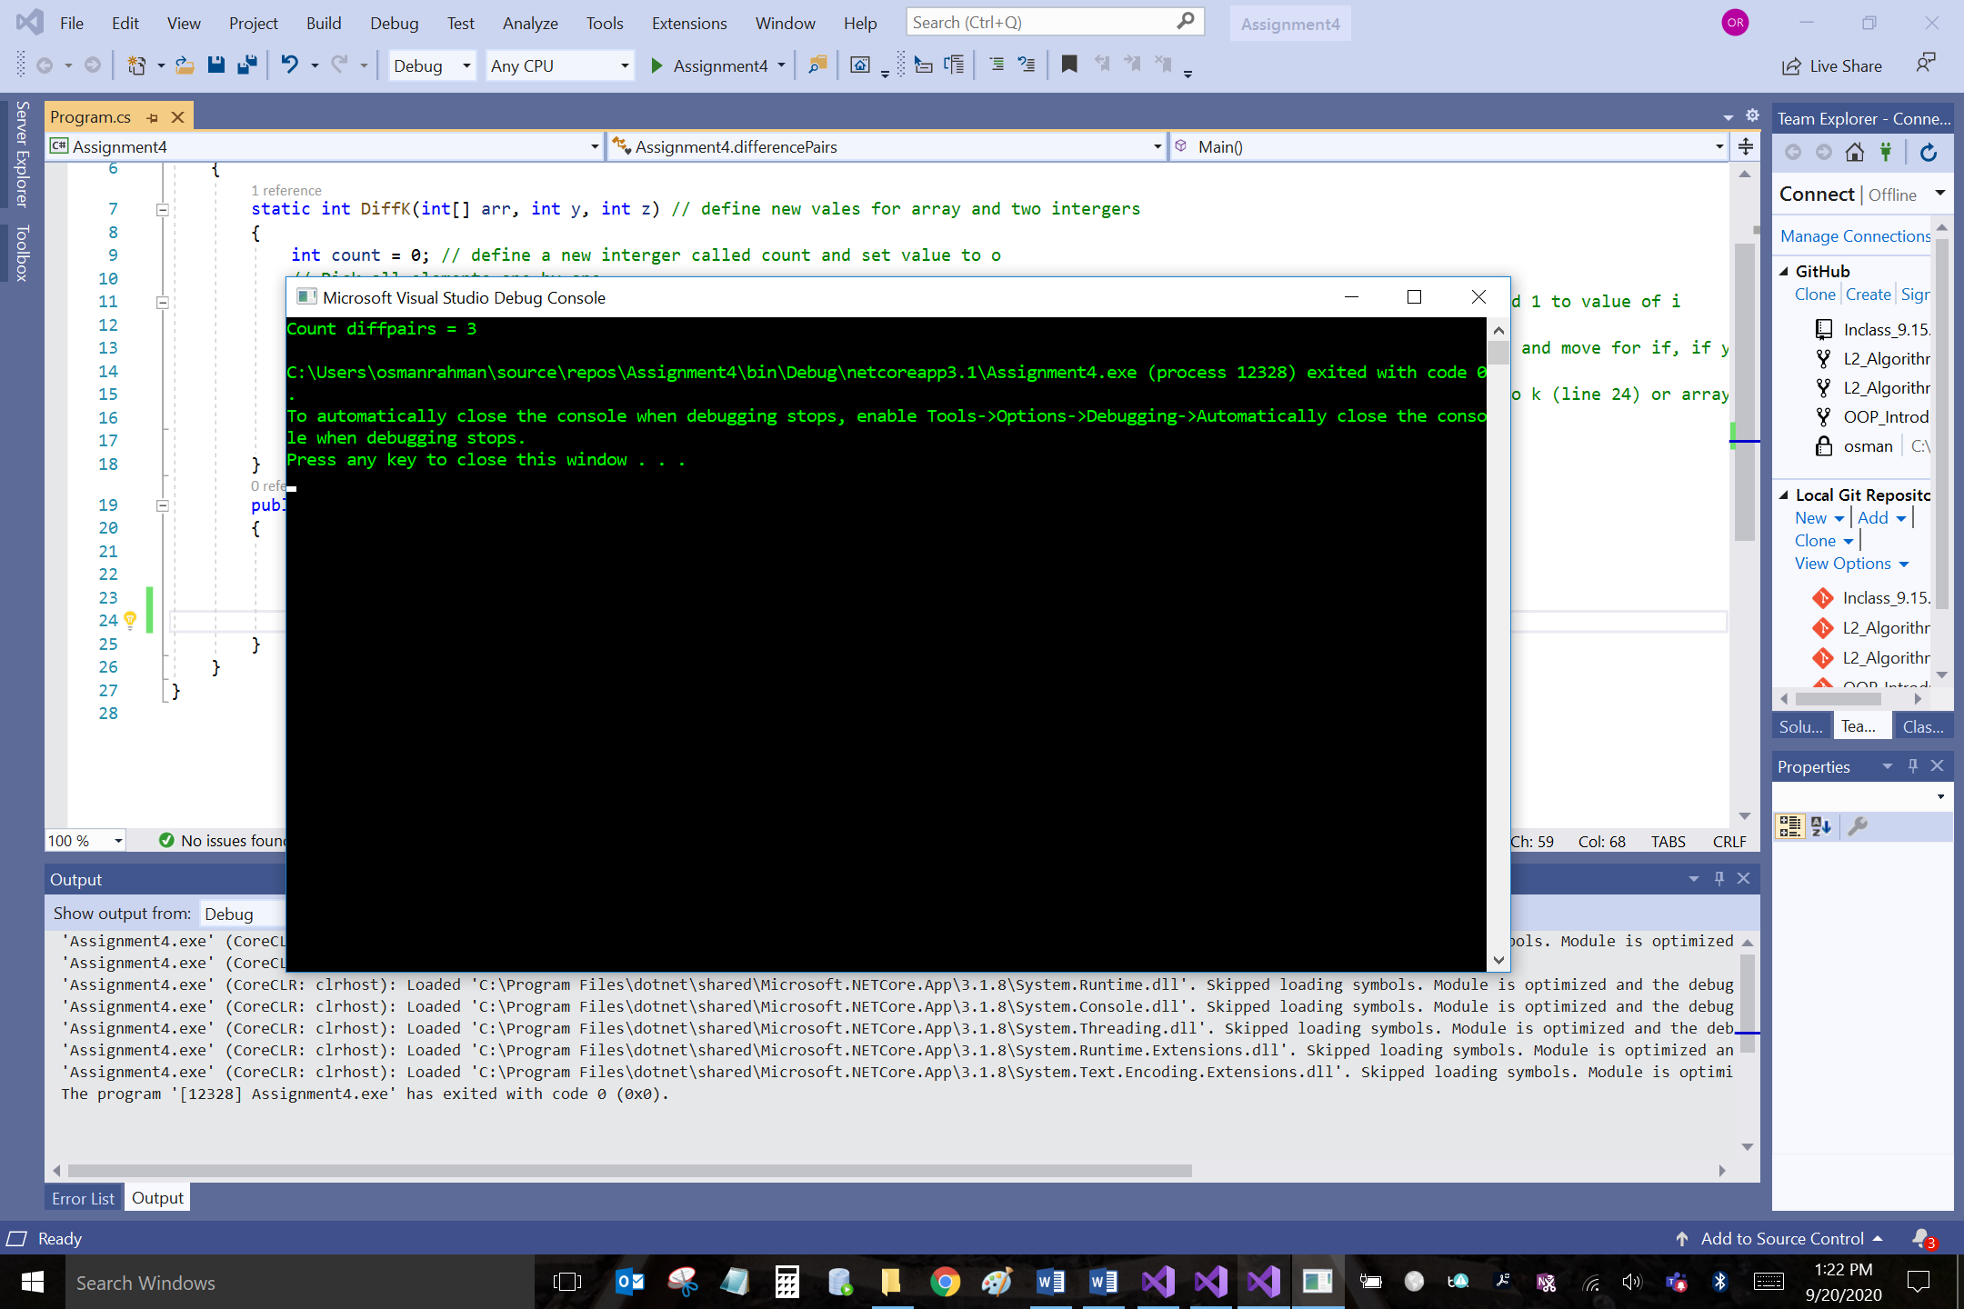

Question 5

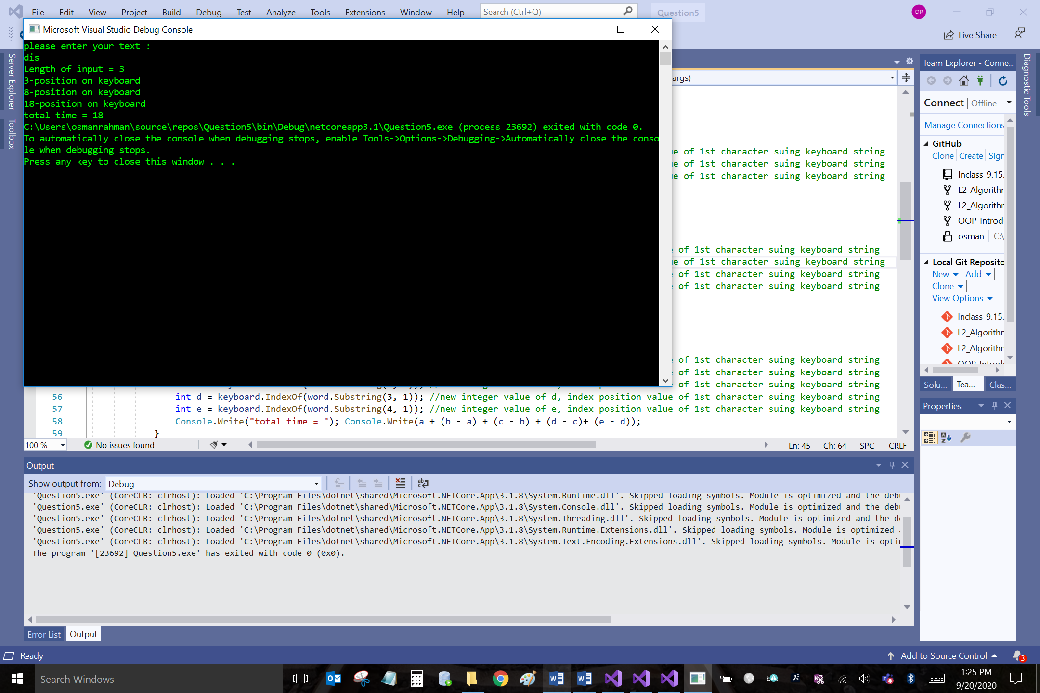

Question 6

